NETWORK TRAFFIC FORENSICS INVESTIGATION REPORT
Packet-Level Analysis of ICMP Communication and TCP SYN Reconnaissance

Prepared By
Samruddhi Bhasme
Project Domain
Cyber Security
Tools Used
- Wireshark
- Nmap
- Kali Linux
Investigation Environment
Controlled Local Laboratory
Report Date
June 2026

Mini Project
A practical investigation demonstrating packet-level analysis of legitimate network communication and reconnaissance traffic using Wireshark and Nmap from a defensive security perspective.
Table of Contents
- Executive Summary
- Project Objective
- Lab Environment
- Investigation Methodology
- Network Architecture
- Investigation 1 – ICMP Echo Analysis
- Investigation 2 – TCP SYN Reconnaissance
- Comparative Traffic Analysis
- Threat Hunting Perspective
- MITRE ATT&CK Mapping
- Detection Recommendations
- Lessons Learned
- Conclusion
- References

1. Executive Summary
Understanding network traffic is one of the core responsibilities of cybersecurity professionals responsible for monitoring and defending enterprise networks. This investigation was conducted to examine how normal communication differs from reconnaissance activity at the packet level using Wireshark.
The project compares ICMP Echo communication generated through the Linux ping utility with TCP SYN reconnaissance generated using Nmap. Both activities were captured and analyzed to understand protocol behavior, packet characteristics, communication patterns, and indicators that help defenders recognize reconnaissance attempts.
The investigation was performed entirely within a controlled laboratory environment using localhost. No external systems were scanned, ensuring the project remained safe, ethical, and privacy-conscious.

2. Project Objective
The primary objectives of this investigation were:
• Capture packet-level network traffic using Wireshark.
• Generate legitimate ICMP communication.
• Simulate TCP SYN reconnaissance using Nmap.
• Compare packet behavior between legitimate and reconnaissance traffic.
• Identify indicators useful for network defenders and SOC analysts.
• Strengthen practical understanding of packet analysis and network protocols.

3. Lab Environment
Component | Description
Operating System | Kali Linux
Analysis Tool | Wireshark
Reconnaissance Tool | Nmap
Capture Interface | Loopback (lo) / Local Interface
Target System | Localhost (127.0.0.1)
Investigation Type | Controlled Laboratory Environment

4. Investigation Methodology
The investigation followed a structured workflow:
Traffic Generation
↓
Packet Capture
↓
Wireshark Display Filters
↓
Packet Inspection
↓
Traffic Comparison
↓
Threat Hunting Analysis
↓
Documentation

5. Network Architecture
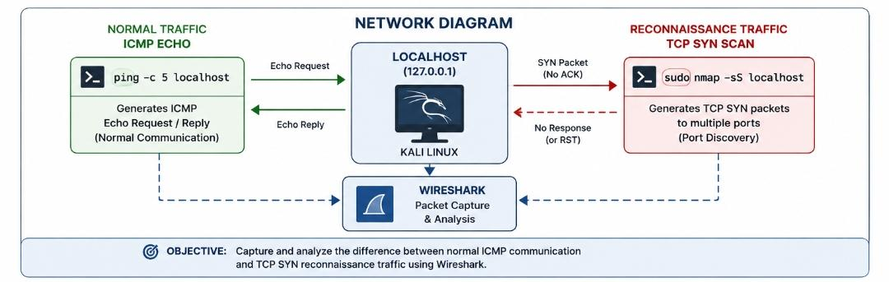
Describe that the packet capture was performed locally, comparing normal ICMP communication with TCP SYN reconnaissance while keeping all traffic within a controlled environment.

6. Investigation 1 – ICMP Echo Analysis
Objective
Capture and analyze legitimate ICMP Echo traffic.
Command Executed
ping -c 5 localhost
Display Filter
icmp
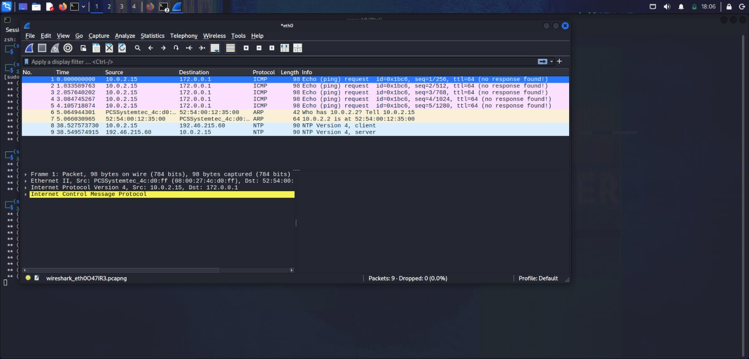
Analysis
The captured packets consisted of ICMP Echo Requests followed immediately by corresponding Echo Replies. The communication demonstrated expected request-response behavior, confirming successful connectivity between the source and destination.
Observations
• ICMP protocol identified
• Echo Request packets observed
• Echo Reply packets received
• Normal communication pattern
• No suspicious behavior detected
Risk Assessment
Low Risk
This traffic represents expected network communication and establishes the baseline used throughout the investigation.

7. Investigation 2 – TCP SYN Reconnaissance
Objective
Capture and analyze reconnaissance traffic generated by an Nmap SYN Scan.
Command Executed
sudo nmap -sS localhost
Display Filter
tcp.flags.syn == 1 && tcp.flags.ack == 0
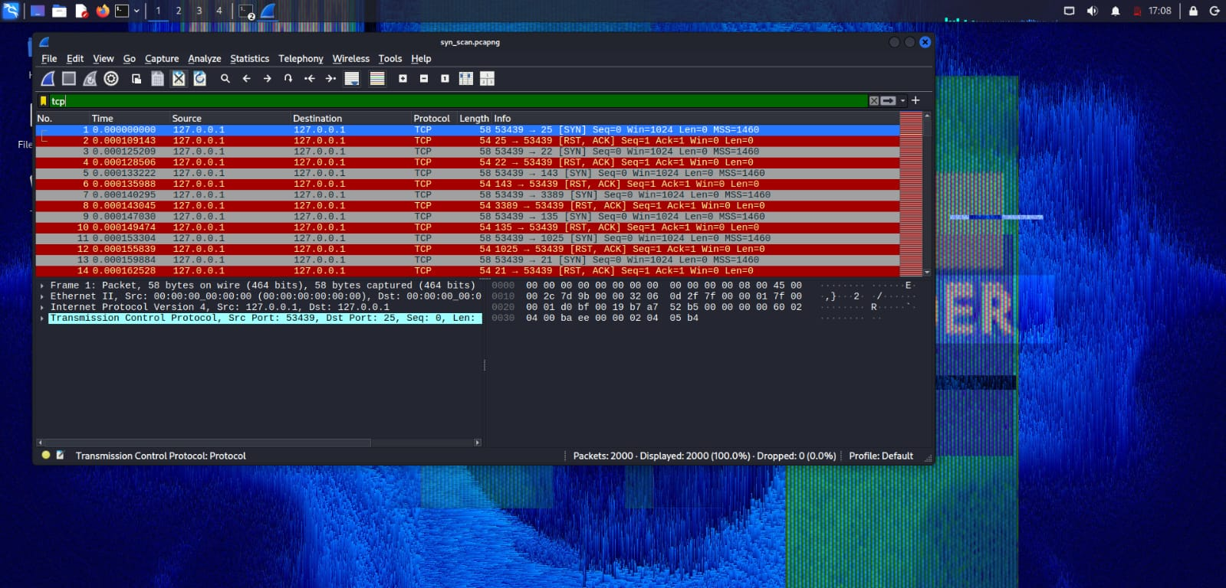
Analysis
The packet capture revealed multiple TCP SYN packets transmitted toward different destination ports. Unlike legitimate communication, the scan intentionally avoided establishing complete TCP sessions, producing a recognizable reconnaissance pattern.
Observations
• Multiple SYN packets detected
• Numerous destination ports targeted
• Half-open TCP behavior observed
• Sequential probing activity
• Reconnaissance characteristics identified
Risk Assessment
Medium Risk
Although generated within a controlled environment, identical packet characteristics are commonly associated with port scanning during the reconnaissance phase of real-world attacks.

8. Comparative Traffic Analysis
Insert the Comparison Table here.
Summarize the primary differences between ICMP Echo communication and TCP SYN reconnaissance, emphasizing protocol behavior, packet structure, communication flow, and defensive interpretation.

9. Threat Hunting Perspective
From a defender's perspective, early identification of reconnaissance activity significantly improves an organization's ability to detect threats before exploitation occurs.
During this investigation, several indicators of reconnaissance were observed:
• Multiple SYN packets generated within a short duration.
• Sequential destination port scanning.
• Incomplete TCP communication.
• Repeated connection attempts.
• Abnormal SYN packet concentration.
These characteristics provide valuable indicators for Security Operations Center (SOC) analysts during network monitoring and incident investigations.

10. MITRE ATT&CK Mapping
Technique | Technique ID
Active Scanning | T1595
Gather Victim Network Information | T1590

11. Detection Recommendations
Based on the observed packet characteristics, the following defensive measures are recommended:
• Monitor excessive TCP SYN traffic.
• Configure intrusion detection signatures for reconnaissance activity.
• Enable firewall logging.
• Investigate repeated connection attempts targeting multiple ports.
• Correlate packet captures with endpoint security telemetry.
• Establish normal traffic baselines to improve anomaly detection.

12. Lessons Learned
This investigation strengthened practical understanding of packet-level communication and reinforced the importance of network traffic analysis in cybersecurity.
Working with Wireshark and Nmap provided valuable insight into how legitimate communication differs from reconnaissance behavior, while also demonstrating how display filters simplify packet investigations.
The project emphasized observation, analysis, and documentation rather than offensive activity, reflecting the mindset required in modern defensive security operations.

13. Conclusion
This investigation successfully demonstrated the differences between legitimate ICMP communication and TCP SYN reconnaissance through packet-level analysis.
The captured traffic illustrated how protocol behavior, TCP flags, and communication patterns can assist defenders in recognizing early-stage reconnaissance activities. Although conducted within a controlled laboratory environment, the observed packet characteristics closely resemble behaviors encountered during real-world security monitoring.
The project strengthened practical skills in packet analysis, protocol interpretation, Wireshark filtering, and technical documentation while reinforcing a defensive approach to network security.

14. References
• Wireshark Official Documentation
• Nmap Reference Guide
• MITRE ATT&CK Framework
• RFC 792 – Internet Control Message Protocol (ICMP)
• RFC 793 – Transmission Control Protocol (TCP)

